Labview Adapter Configuration and API for Source Only VI Feature

Revised: 12/14/2022 10:00 AM
TestStand Version: 2023 Q2
Author: Aman S
Feature Spec:
Dependencies: Perforce

Description
This feature is in TS 2023 Q2 and allows the user to run the VIs in PPL. TS behind the scenes collates the VI’s and builds the PPL. An LV development system should be present for the PPL build to happen. This would enable the user to have better execution times.
This test can be tested with either 32-Bit and 64-Bit LabVIEW and TestStand.

Preparation
- Install TestStand 2023 Q2 or later
- Install LabVIEW 2022 or older.
- For TestStand 2023, the feature would be behind the ‘BuildAndExecuteLVSource’ feature toggle.
The new option added as part of this feature is called ‘Enable Build Distribution and Execute’
- Use Media mentioned in this test plan from //TestStand/WebPages/TestCases/Adapters/LabVIEW/Media/SourceOnlyVI.

Validation

Steps for LabVIEW adapter UI:

[Section: Without valid LabVIEW version]
- Launch TestStand and open the LabVIEW configuration dialog. ( Configure -> Adapter > Select “Labview”)
- The new option control ‘Enable Build Distribution and Execute’ should be disabled and the label should read:
"The 'Build Distribution and Execute' option is disabled because LabVIEW Development System 2023 Q1 or higher of the matching bitness is not active. Refer to the 'Build Distribution and Execute' help topic for more information."
- Close the dialog and exit TestStand.
[section]
- Install LabVIEW 2023 Q1 or later and launch it.
- Feature toggle disabled: Launch TestStand without feature toggle and make sure the LabVIEW adapter dialog looks like the below image
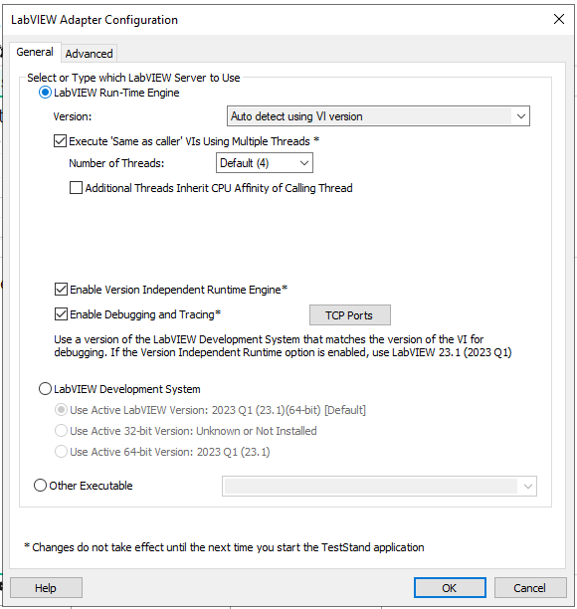
- Feature toggle enabled: Launch TestStand with feature toggle and the adapter dialog should look like below image. The label for ‘Enable Build Distribution and Execute’ option should read:
“Enabling 'Build Distribution and Execute' will also enable the 'Enable Version Independent Runtime Engine' option and ignore 'Always run VI in Packed Project Library' option. Refer to the 'Build Distribution and Execute' help topic for more information.”
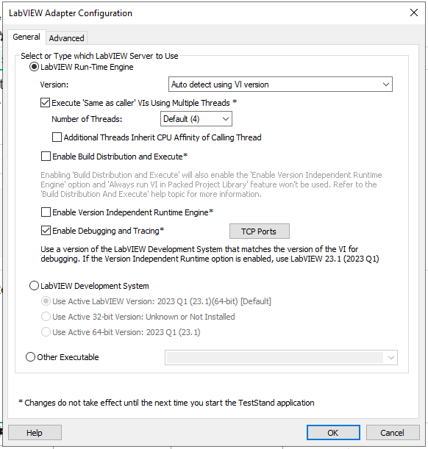
- Go to advanced tab. 'Always run VI in Packed Project Library’ and ‘Automatically build PPLs at the start of execution’ controls should not be disabled (greyed out) if the new option was not checked (true) at TestStand launch.
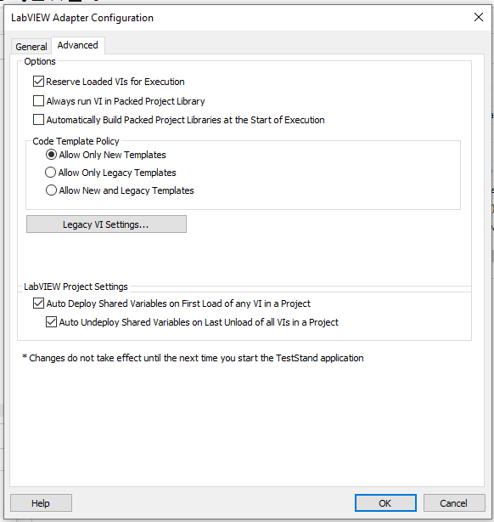
[section]
- Set ‘Enable Build Distribution and Execute’ option. This should automatically check the ‘Enable Version Independent Runtime Engine’ (BCRTE) option and disable the control.
- It should also disable ‘Version’ combo-box under ‘LabVIEW Run-Time Engine’ and select ‘Auto detect using VI version’, since BCRTE is set.
- Click on OK and relaunch the dialog. The settings should persist.
- Click on OK again, and restart TestStand.
- Launch the dialog again. The settings should persist.
- Go to advanced tab. 'Always run VI in Packed Project Library’ and ‘Automatically build PPLs at the start of execution’ controls should now be disabled (greyed out) as new option was set at TestStand launch.
- Change adapter to use ‘LabVIEW Development System’. The label should now display:
"The 'Build Distribution and Execute' option is disabled because it is only applicable when the 'LabVIEW Run-Time Engine' is set as the LabVIEW Server. Refer to the 'Build Distribution and Execute' help topic for more information."
- Go to advance tab. The two controls should now be enabled (not greyed out) since the new feature is not applicable anymore when using LabVIEW dev.
- Click OK and relaunch dialog. The settings should persist.
- Change adapter to use LV Runtime engine and switch to advanced tab. The controls should be disabled now.
- Change adapter to use LabVIEW dev again and restart TestStand.
- Launch the dialog again and open advanced tab. The controls should be enabled. Go to the general page and switch to LV RTE.
- The controls should now be disabled (because even though LV dev was selected, the option was still set at startup and all conditions for the feature were met). Click on Ok and close dialog.
[section]
- Shut down TestStand and any open LV instances.
- Launch LabVIEW 2022 to make it the active LV version.
- Launch TestStand and open the dialog, the Build and Execute option should be disabled, and the label should display
"The 'Build Distribution and Execute' option is disabled because LabVIEW Development System 2023 Q1 or higher of the matching bitness is not active. Refer to the 'Build Distribution and Execute' help topic for more information."
- Close LV2022 and launch LV2023 and shutdown TestStand.
[section]
- Close TestStand and make a copy of NIPBSupport2018.lvlibp from ‘<TestStand installed folder>\Components\Tools\Deployment Utility’ folder and delete it.
- Launch TestStand and open the LabVIEW dialog. The Build and Execute option should be disabled as shown below and the label should display
"The 'Build Distribution and Execute' option is disabled because 'TestStand Tools' component was not found on the system. Refer to the 'Build Distribution and Execute' help topic for more information."
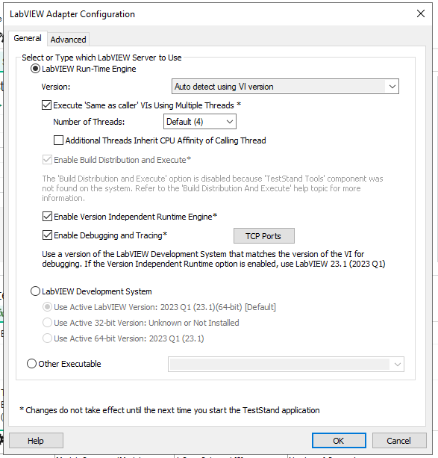
- Close TestStand and restore NIPBSupport2018.lvlibp.
- Launch TestStand and open the dialog. The Build and Execute option should be enabled.

Steps for new APIs:
- Launch TestStand with feature toggle
- Open LabVIEW adapter settings and uncheck the option ‘Build Distribution and Execute’
- Open the sequence ‘Test_API.seq’
- Execute the sequence. It should enable the Build and Execute option using API.
- Restart TestStand
- Open the LV adapter dialog. The option should be checked and BCRTE should be checked and disabled.
- Open the sequence again. Click on the step and go to step settings.
- Change the command to set the value to false (to disable the option)
- Execute the sequence and restart TestStand
- Launch LV adapter dialog and now the Build and Execute option should be unchecked.

Warning/Information error provider in adapter dialog:
- In LabVIEW adapter dialog, in general tab, verify that if you modify any of the following settings (compared to what exists when you launched TestStand), you will get warning next to the control with a tooltip specifying that the updated value is honored only after restarting TestStand.
  - Execute ‘Same as caller’ Vis using Multiple Threads.
  - Enable Build Source Files and Execute
  - Enable Version Independent Runtime Engine
  - Enable Debugging and Tracing
- When ‘Build Source Files and Execute’ option is enabled during launch of TestStand, verify that in Advanced tab of adapter settings, ‘Always run VI in PPL’ and ‘Automatically Build PPL’ will be disabled. Verify that information is displayed next to disabled controls with tooltip mentioning that control is disabled due to Build Source Files and Execute.

BCRTE warning message

- We need to ensure that the following warning message is not displayed if Build and Execute feature is enabled.
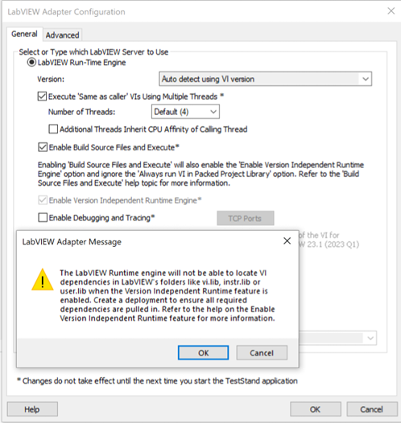
- Open LV adapter dialog.
- Uncheck Build and execute and Version independent engine
- Save and restart TS
- Open the dialog and only check Version independent runtime engine. Hit ok.
- You should get a warning dialog like above.
- Uncheck the option and restart TS
- Now check only Build and execute option
- Version independent engine should also be checked and on hitting ok no warning dialog should be shown.

- National Instruments Confidential
Copyright © 2014 National Instruments Corporation

